The Art of Narrative: Charles White and Diego Rivera
Name of Student
Course
Professor
Date of Submission

Introduction
The first artwork I chose to analyze was “Mary McLeod Bethune” by Charles White. This artwork is very similar to Diego Rivera’s “Portrait of America” because they both have a group of people, and the artists used many similar elements. They fall under the categories of portrait and mural because both artists paint people and their foregrounds are usually large murals. The figurative subject matter of this painting is Charles White, the painter himself. For Diego, it’s the United States. Both artists are painting themselves, but Charles White has a very different approach because he used color to symbolize certain parts of his identity in his self-portrait.
The painting looks very different from any other self-portrait I’ve seen. Charles White used a lot of color in his work, which was not common for artists during this period. He uses red to symbolize his Mexican ancestry and blue to represent his African American identity. He paints himself with a small woman next to him, representing Mary McLeod Bethune (the person he is painting). Diego Rivera’s mural is very colorful, and the foreground includes a portrait of America. It has many figures in it, representing different ethnicities and cultures that contribute to society. Diego uses his artwork to show how everyone can work together for society to function properly so we can grow stronger every day.
The elements of design that I found in this painting are line, shape, light and value, color, texture. The characteristics of Charles White’s self-portrait were painted with many straight lines to show strength and power because he is an African American man. He also used very bright colors like blue for his skin tone, which symbolizes the ethnicities of African Americans. The principles of design that I found in this painting are unity, proportion, and emphasis or subordination. Charles White used the entire canvas to show how important Mary McLeod Bethune was because he wouldn’t have achieved so much success as an artist without her. The elements in Diego’s mural are line, shape, color, and texture. He uses a lot of straight lines to show how everyone is working together for society to function properly. He has men holding onto each other on the bottom right-hand side of his work like they’re all one big family that works together. The principles of design I find in this painting are balance, unity, and emphasis or subordination. Diego Rivera used many colors to show that everyone has an important role in society because if one person is missing, the whole system will collapse.
Conclusion
These two artworks can be interpreted in many different ways because they both have strong messages and symbolism. I also think that they are both powerful works of art because very talented artists created them. They can teach us so much about working together in society, and I can tell that both Charles White and Diego Rivera did not want their artworks to be forgotten.

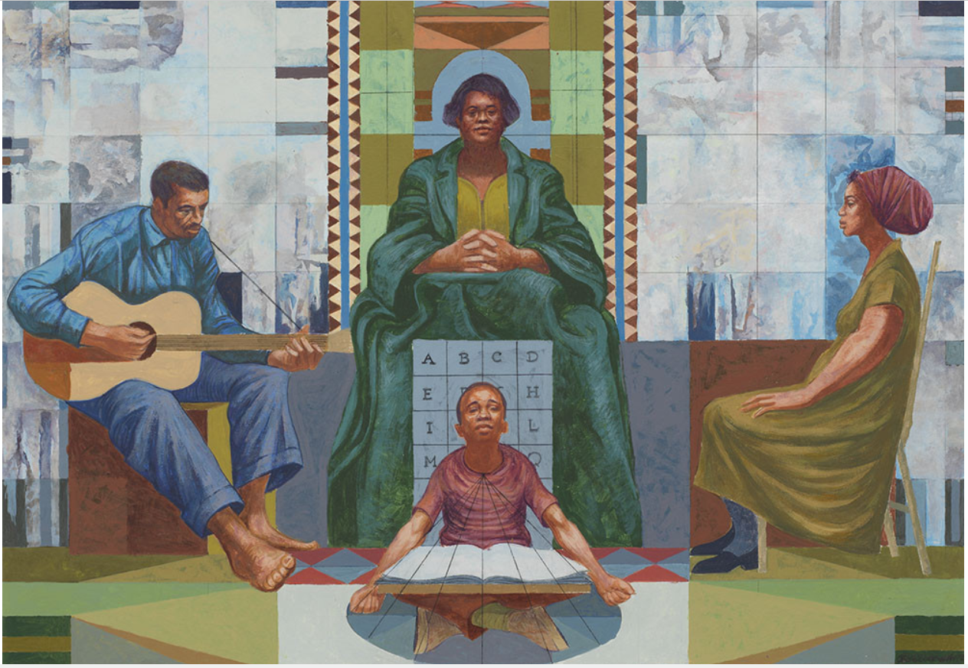
Figure 1 Charles White, presentation study for Mary McLeod Bethune Mural, 1977–78
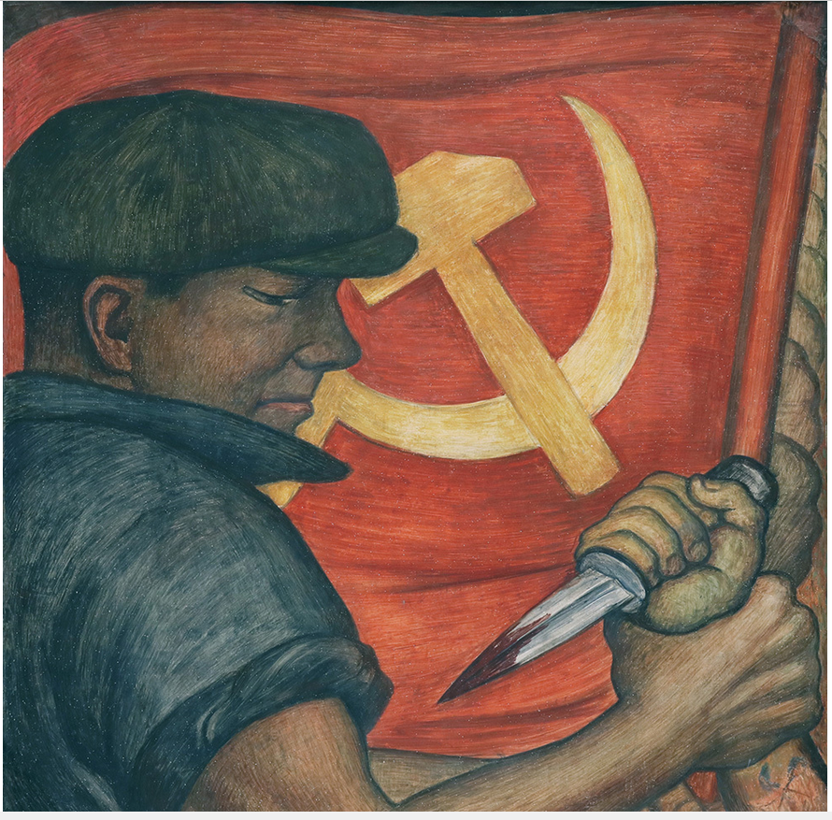
Figure 2 Diego Rivera, Opponent of Nazism, from Portrait of America, 1933

